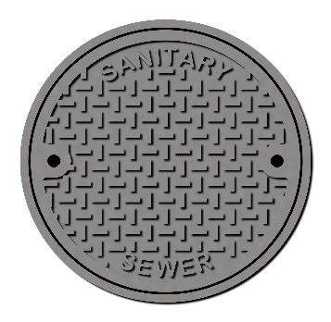
WABENO SANITARY DISTRICT NO. 1
1735 THIRD ST., P O BOX 4
WABENO, WI 54566
W A B E N O
OFFICE: 715-473-2905
FAX: 715-473-2033
wsd328@centurytel.net

Regular Meeting
October 3, 2022 10:00am
Wabeno Sanitary District No. 1 Office
Board of Commissioners

- Call to Order.
- Personal Appearances and Public Input.
- Guest-RT from Northern Lakes Labs.
- Review and Possibly Approve Minutes of the September 6, 2022 Regular and Closed Meetings.
- Meeting Financial Report.
- Discussion and Possible Action on Capital Improvement Ideas.
- Discussion and Possible Action on Contractors Using our Waste Water System.
- Discussion and Possible Action on ARPA Funds from Town of Wabeno Update.
- Clerk’s Report:
- Operator’s Report:
- BOD’s, TSS’s & Ammonia.
- Review and Possibly Approve Vouchers and Checks.
- Member Items.
- Next Meeting Date.
- Motion to Go into Closed Meeting. Under WI State Statute 19.85(1)(c) to discuss employment, promotion, compensation or performance evaluation data of any public employee over which the governmental body has jurisdiction or exercises responsibility.
- Return to Open Session.
- Action, if any, on matters of employment.
- Adjourn.

Note: This agenda could be subject to changes. Any changes will be posted at 1735 Third St. Office, Laona State Bank (Wabeno Branch) and Wabeno Post Office 24 hours in advance of a meeting and/or no later than two (2) hours prior to a meeting called for good cause under State Statute 19.84(3).

Mission Statement: “To provide safe high quality drinking water and maintain an environmentally
safe wastewater treatment system ensuring pride in our community
where we work and play…”

